Fabrication notes for <Board 2 – Housing and Samtech>

**Designer contact: Jacky Li,** [**jackymengyangli@uchicago.edu**](mailto:jackymengyangli@uchicago.edu)

**Board Stack Info:** 4 layer board, 1.6 mm thickness, 1/1 oz Cu. Size 9.65 * 11.79 in.

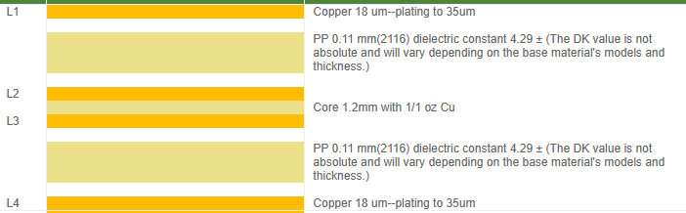

There are traces on L4, they couple to L3. We want impedance control on these to be 50 ohms.